**“Unicom TIC Management system”**

Miss.Darsika Kunarasa.

UT010503

Guidance of

Mr.Kathir

Date:24.06.2025

**Unicom TIC Management System - Final Project Report**

1. **Project Overview**

The Unicom TIC Management System is a desktop-based application designed for school management.

It supports the management of courses, subjects, students, exams, marks, and timetables, with login-based access control.

The application allows Admin, Staff, Students, and Lecturers to interact with the system based on their roles.

**2. Key Features**

- Role-based Login (Admin, Staff, Student, Lecturer)

- Add/Edit/Delete Courses and Subjects

- Student Management linked to Courses

- Exam and Marks Management per Subject

- View Marks and Timetables by role

- Input Validation and Message Feedback

**3. Technologies Used**

- Language: C#

- Framework: .NET WinForms

- Database: SQLite

- Design Pattern: MVC (Model-View-Controller)

- Libraries: System.Data.SQLite

**4. Challenges Faced and Solutions**

1. Role-based form control visibility was tricky at first, but solved by passing the user role to the MainForm and applying conditional logic.

2. SQLite file not generating was solved by calling table creation scripts during app startup.

3. Hidden labels and invisible components were made editable using Document Outline view in Visual Studio.

**5.Form Design(Login Form , Main Form)**

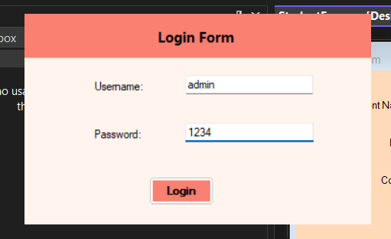

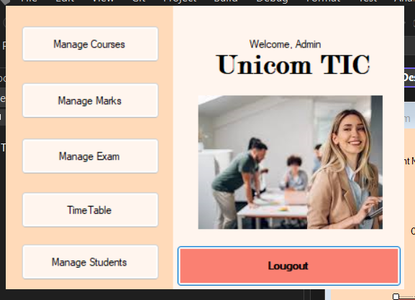

**6. Code Samples (ScreenShotes )**

**Login Validation Method**

1. LoginController.cs

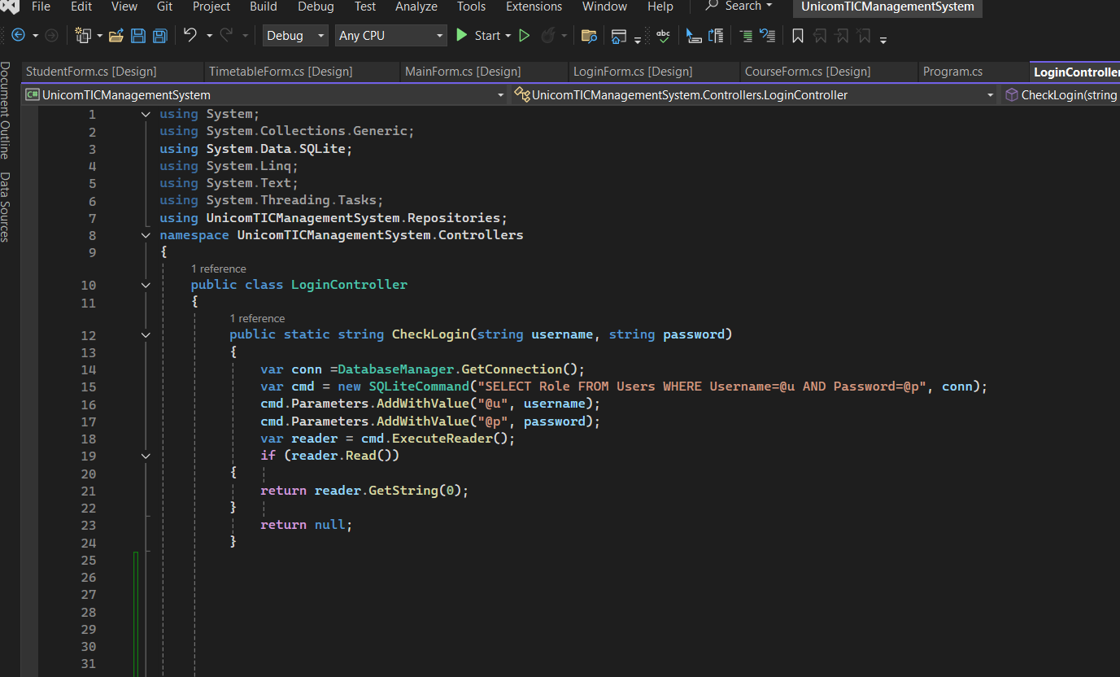

1. MainForm button visibility logic based on role

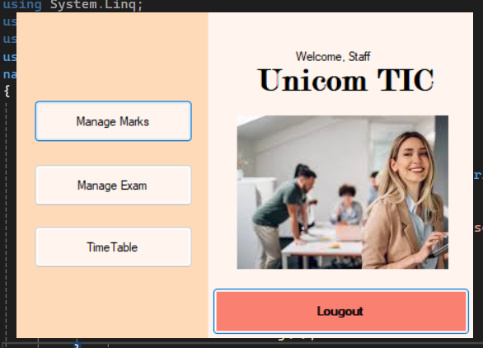

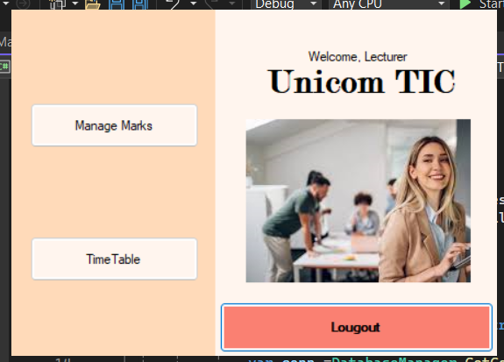

1. Course Logic

-Course controller

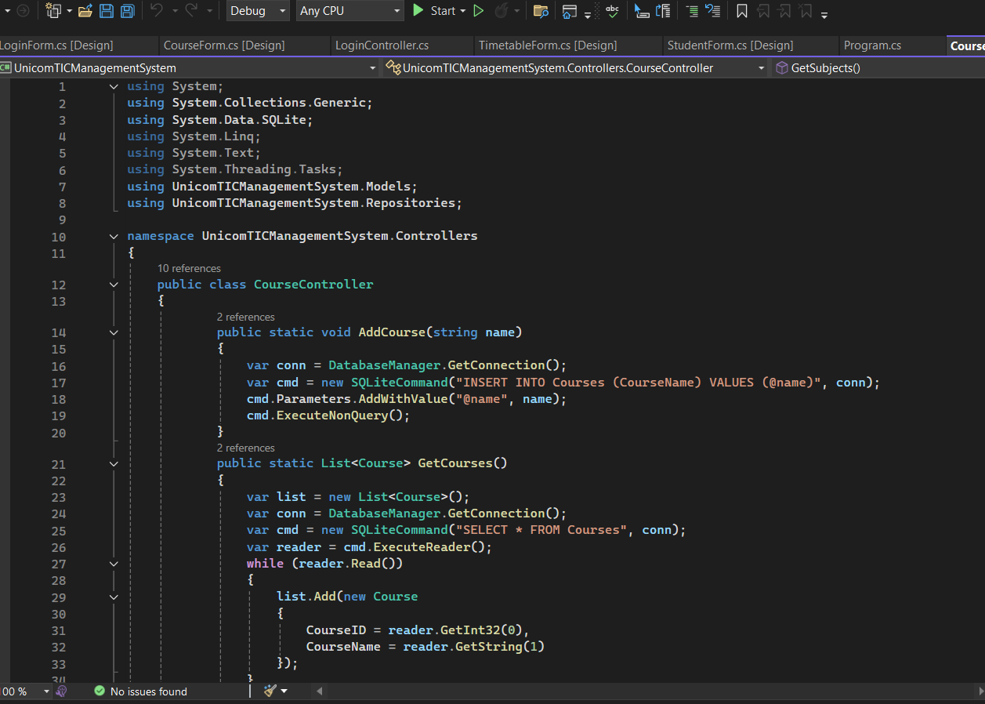

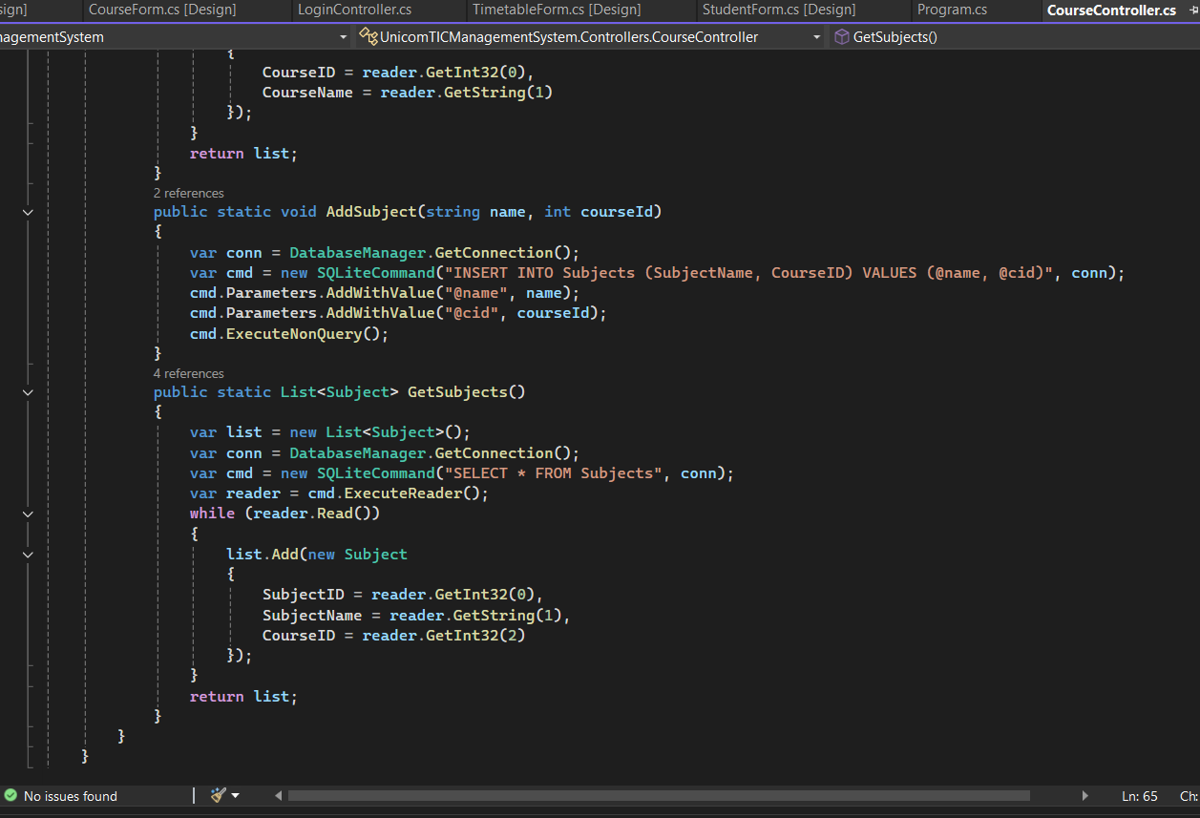

-courseForm.cs

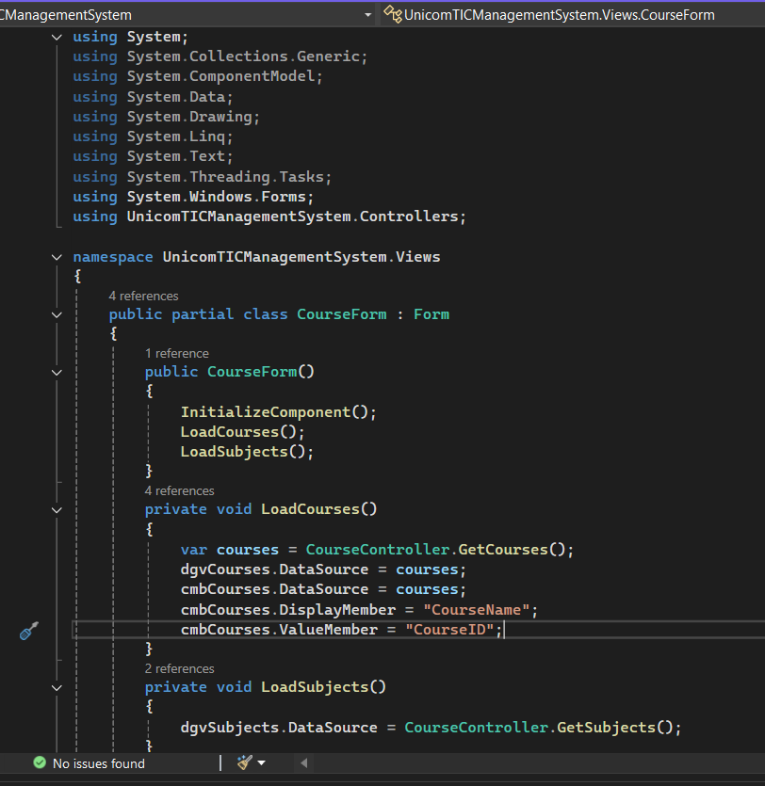

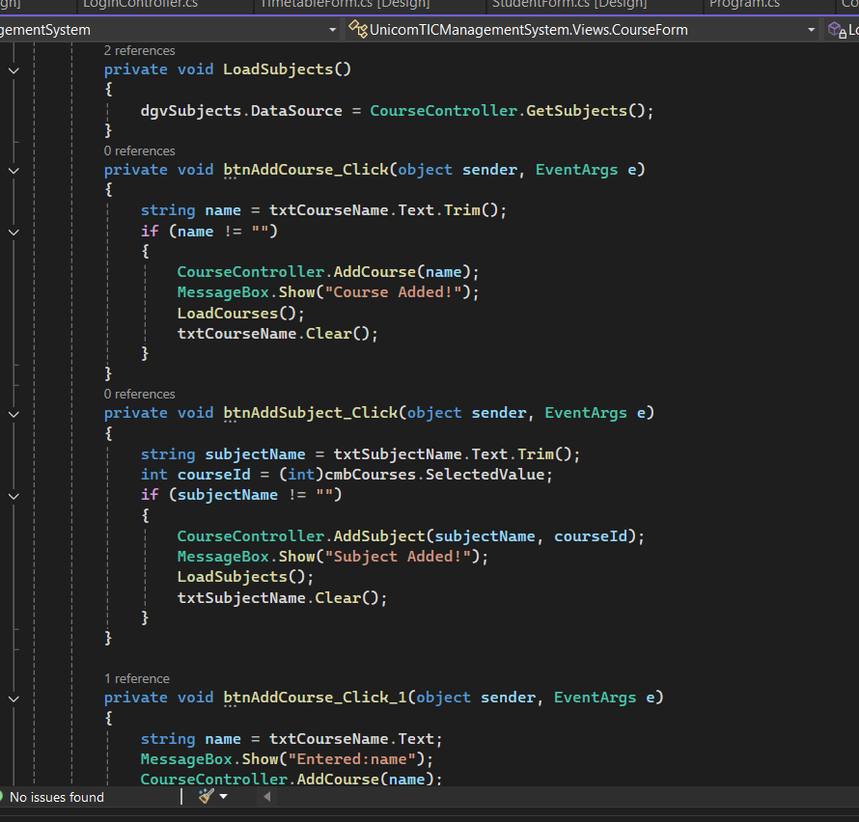

1. DatabaseManager.cs

